IMPACT OF COVID-19 IN TOURISM INDUSTRY
Muskan Nahar & Resham Solanki

Abstract
Tourism, one of the largest and fastest developing sectors has been taken into consideration as a vulnerable industry i.e. in assessment to different industries; tourism enterprise gets more affected due to any outside or inner shocks or stresses. The corona virus ailment (COVID-19) is a brand new pandemic that spreads broadly speaking via touch with an infected individual when they cough or sneeze. The COVID-19 is a disease causes respiratory infection with signs and symptoms consisting of a cough, fever and in more severe cases, issue breathing. The outbreak of COVID19 has started out in China then spreading to global that contributes to large range of deaths (4, 51,569 deaths, 18th June 2020). To preventing spread of this pandemic, many nations carried out lockdown procedure to stop the chain of infection for this new disorder. The authorities ordered lockdowns which have disrupted existence for billions and in the same time it created financial disintegrate scenario. In this regard, the state-of-the-art outbreak of Corona (COVID-19) virus has prompted immense problems across the world. The country with the most COVID-19 infections suggested a document surge in unemployment. The study calculates the effect of COVID-19 to tourism enterprise for affected countries within the globe. The intention of this paper is to acquire the influences of the virus on diverse country wide and global tourism policies, inflow, outflow, and tourism sector as a whole. It additionally evaluated the changes in tourism enterprise of diverse countries. The end result indicates COVID-19 creates panic amongst public that contributes to decrease call for in tourism enterprise. This is considered one of the impacts because, of sickness spreading such as lockdown approach that applied in modern situation. This scenario, contributes to decrease demand charge via customer.
KEYWORDS: COVID-19, travel restrictions, decrement, global change, pandemic, airlines, cruise and hotel

Introduction
The COVID-19 epidemic has a major impact on the tourism industry due to the high travel restrictions and the lack of demand among travelers. The tourism industry has been heavily affected by the spread of the corona virus, as many countries have introduced travel restrictions in an effort to curb its spread. The United Nations World Tourism Organization estimates that global tourism arrivals may decline by 20-30% by 2020, leading to an estimated loss of 30-50 billion Americans. In most cities of the world, scheduled travel has dropped 80-90%.
As a result of the epidemic, many countries and regions have imposed accommodation, entry barriers, or other restrictions on residents of travelers or newcomers to the most affected areas. Some countries and regions have set international restrictions that apply to all countries and countries, or prevent their citizens from traveling abroad. Industries such as: casinos, airports, boating, hotels, restaurants etc. They are also affected by the disease. Some have used the airline's opportunity to significantly reduce their costs for travel and leisure activities despite repeated warnings not to stay home, as well as the need to isolate themselves for two weeks upon arrival or return from travel.
A large number of college students tested positive for COVID-19 after returning from different locations. If the epidemic goes on for a few short months, the Council on Tourism and Tourism, a trade group representing the world's largest travel companies, foresees a global loss of 75 million jobs. The International Air Transport Association estimates that the industry could lose as much as R340 million in revenue by 2020 due to a corona virus. The COVID-19 epidemic and the measures put in place to contain its disadvantages have a serious impact on the tourism sector.
The Indian economy has experienced a sharp decline in the last few quarters. In the third quarter of the current fiscal, the economy grew at a six-year low of 4.7%. There was a strong prospect of recovery in the last quarter of the current fiscal. However, this new corona virus epidemic has made it very difficult to recover in the near and medium term. The outbreak posed new challenges for the Indian economy now, making a significant disruptive impact on both demand and providing marginal resources with the potential to slow India's growth issue. India announced its first confirmed case on January 30.
However, there are some signs of public transit - the percentage of affected people is still low, and most of the cases are travel related. That means, the home environment is always moist and the warranties are monitored regularly. The impact on the Indian economy could be greater if the virus continues to enter the country which will have a lasting impact. While the impact on economic prospects due to employment affects countries such as China, S Korea, Japan, Italy, etc. It can be through trade, investment and service routes, it can be far more damaging if there is a closure of India.
The purpose of the study is to understand the opinion from business executives on the high risk in the Indian economy after the recent outbreak and spread of the virus.
According to the United Nations World Tourism Organization (UNWTO), the COVID-19 epidemic will result in a decline in the tourism industry by 20% to 30% by 2020.These estimates are likely to be decreasing in countries dependent on foreign tourists, as recent data on daily vehicles shows a nearly 80% decrease from January 2020.While many economic sectors are expected to be set back once the routes have been blocked once proposed, the epidemic is likely to have a long-term impact on international tourism. This is due to reduced consumer spending and long-term travel opportunities abroad.
According to the World Travel and Tourism Council (WTTC), in previous epidemics the virus was the time-traveling virus they visited on average around 19 months.

Result Analysis and Data Interpretation
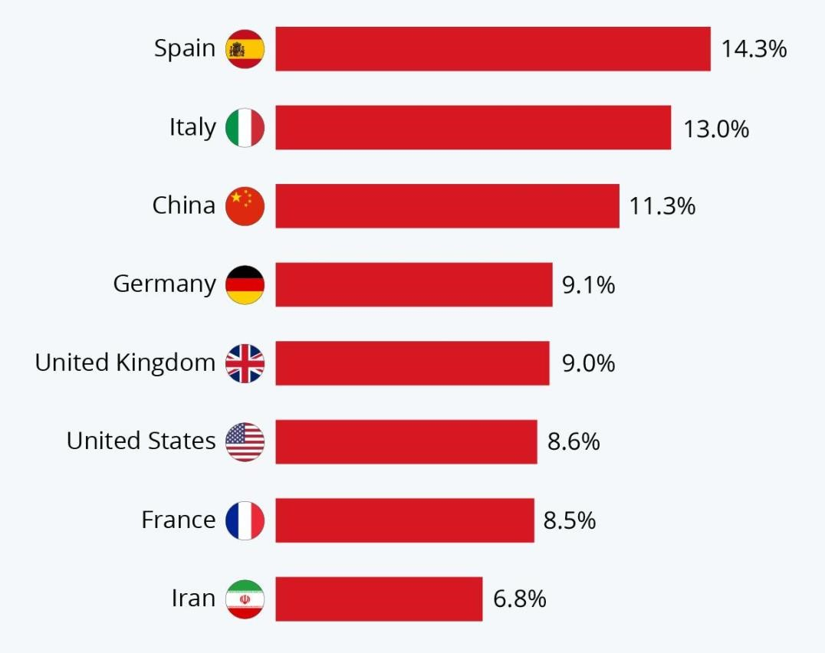
This shows the impact of the tourism epidemic and the GDP of selected countries. Spain is a country most vulnerable to the impact of covid-19 on tourism and like Iran there is very little.

Impact of Covid19 in Various Countries

Spain
Arrivals in March 2020 dropped 64 percent a year.

Sri Lanka
Arrivals in March 2020 dropped 70.8% year-on-year.

India
Foreign arrivals in March 2020 decreased by 66.4%

Indonesia
Arrivals in March 2020 decreased by 64.11% year-on-year.

Japan
Arrivals in March 2020 dropped 94% year-on-year.

United States
Hawaii nearly shut down tourism and tourist arrivals in Hawaii were down 99.5% in April 2020. With its people arriving, the last fourteen days. Dozens of tourists who came to the island but did not follow the six-day bond for 14 days were arrested. In June 2020 Hawaii had not set a date for the island to resume tourism. As of June 16, the sole residence would be developed for tourism on the island. Florida Tourism had an annual decline of over 10.7% in the first quarter of 2020.

Malaysia
On March 16, 2020, the Ministry of Tourism, Arts and Culture announces that a few tourist destinations around Malawi will remain closed until 30 March 2020 which includes a tourist information center, National Arts Gallery, handicrafts, Lenggong Archaeological Museum, National Archives of Malaysia, memorial Center and National Library of Malaysia.

Mexico
The Conjojo National Empresarial Touristic (National Tourism Business Council, CNET) sent two letters in March to Alfonso Romo, Chief of Staff to the President of Mexico, outlining the importance of tourism to the economy and calling for government support for the sector. Tourism offers four million jobs in Mexico, while 93% of companies have 10 or fewer employees. The epidemic has caused the closure of 4,000 hotels (52,400 rooms) and 2,000 restaurants, while the aviation industry lost MXN $ 30 billion (US $ 1.3 billion) in March.

Australia
Tourism agencies have projected that the total economic cost for the sector, as of 11 February 2020, will be $ 4.5 billion. Casino earnings are expected to fall. At least two locations in Australia, Cairns and the Gold Coast, have reported revenues of over $ 600 million.
The Australian Tourism Industry Council (ATIC) has also called on the Australian Government for funding especially the large number of small businesses affected.
The national flight agency Flight Center permanently closed 100 stores across Australia, due to the very low travel demand. It is also down by 75% on the stock price, the cancellation of the declared dividend, and the sharing of the trading suspension, and announces that 6,000 workers will be reduced or placed on unpaid internationally.

Impact of Covid19 in Various Sectors
Casino Industry
In Macau, the world's top gambling destination, all casinos closed for 15 days in February 2020 and an annual decrease of 88%, the worst ever recorded in the region. On March 17, Nevada Governor Steve Sisolak ordered that all casinos be shut down for 30 days.

Cruise Industry
The cables had to cancel sailing following the outbreak. Reservations and cancellations have increased as the mass media coverage of sick passengers on boarded vessels has damaged the industry's image. In May 2020, Norway's Cruise Line posted a quarterly loss of $ 1.88 billion and warned it could end business

Hotel Industry
On April 11, 2020, only 3 percent of hotels were located in Austin, Texas. As of today, there were 342 rooms, compared to the 10,777 rooms on the same day in 2019.

Rental Car Industry
Hertz Global Holdings Inc. filed for Chapter 11 bankruptcy on May 22, 2020. It has not yet been funded for the United States to designate aviation bail.

Restaurant Industry
The epidemic has affected the global food industry as authorities close restaurants and bars to reduce the spread of the virus. Globally, daily grocery sales have decreased compared to the same period in 2019. The closure of restaurants has resulted in a complex effect between related industries such as food production, alcohol-, wine- and beer production, food and beverage distribution, fishing, and farming.

Findings
According to this paper,
- The World Tourism and Tourism Council has warned that the COVID-19 epidemic could reduce 50 million jobs worldwide in the travel and tourism industry.
- Asia is expected to be the most affected.
- Once the outbreak is complete, it can take up to 10 months for the industry to recover.
- The tourism industry currently accounts for 10% of global GDP.

Conclusion
The travel and tourism business is largely on its knees worldwide. The borders of the country are closed. Cities are still standing. Flights are booked. It is sailing. Trains and buses don't go. Hotels and restaurants are closed. No one knows when the viral load will go down; no vaccine appears; people are gathered into their houses. Social media is the new mantra. Masks and gloves are a new offering for security. And no one even thinks about vacation, let alone planning it. India attracted 10.5 million foreign visitors last year; 5 million NRIs returned home to live with family and friends.
About 1.8 billion Indians travel across the country on holidays, and 26 million Indians travel abroad for tours. All these figures look like a far cry from today. With current indications, gardens and curfews can pull through to the end of this year with varying strengths and capabilities. No one really knows, or can accurately predict how all this will go, going forward. Although offices and restaurants are reopening soon, it will take a long time to get to the supermarkets, the gym, the stadiums and other densely populated areas to return to broadcast.
Countries such as Italy and Spain, even Germany and the UK, as well as the US, have recorded a large number of corona deaths that may not have as many tourists in the near future. It will take some time for these countries to regain their beauty. The best case scenario is that recovery will start in the tourist sector hitting the short, with driving families gaining experience with their vehicles. After that slowly, as the edges are removed, there will be a gradual recovery in all parts.

2nd Year, Student, BBA Global
2nd Year, Student, BBA Global
"The long-term effects of the coronavirus". The Jerusalem Post, JPost.com. Retrieved 12 March 2020.
Taylor, Josh, Completely dropped off': Australia's tourism industry braces for coronavirus crisis, The Guardian. ISSN 0261-3077, (11 February 2020). Archived from the original on 11
Butler, Ben, Coronavirus threatens Australian economy reeling from drought and fires, The Guardian. ISSN 0261-3077. Archived from the original on 6 February 2020. Retrieved 12 February 2020.

